**Star Wars (Star Ship – Amount Stop Calculation)**

**Developer Manual**

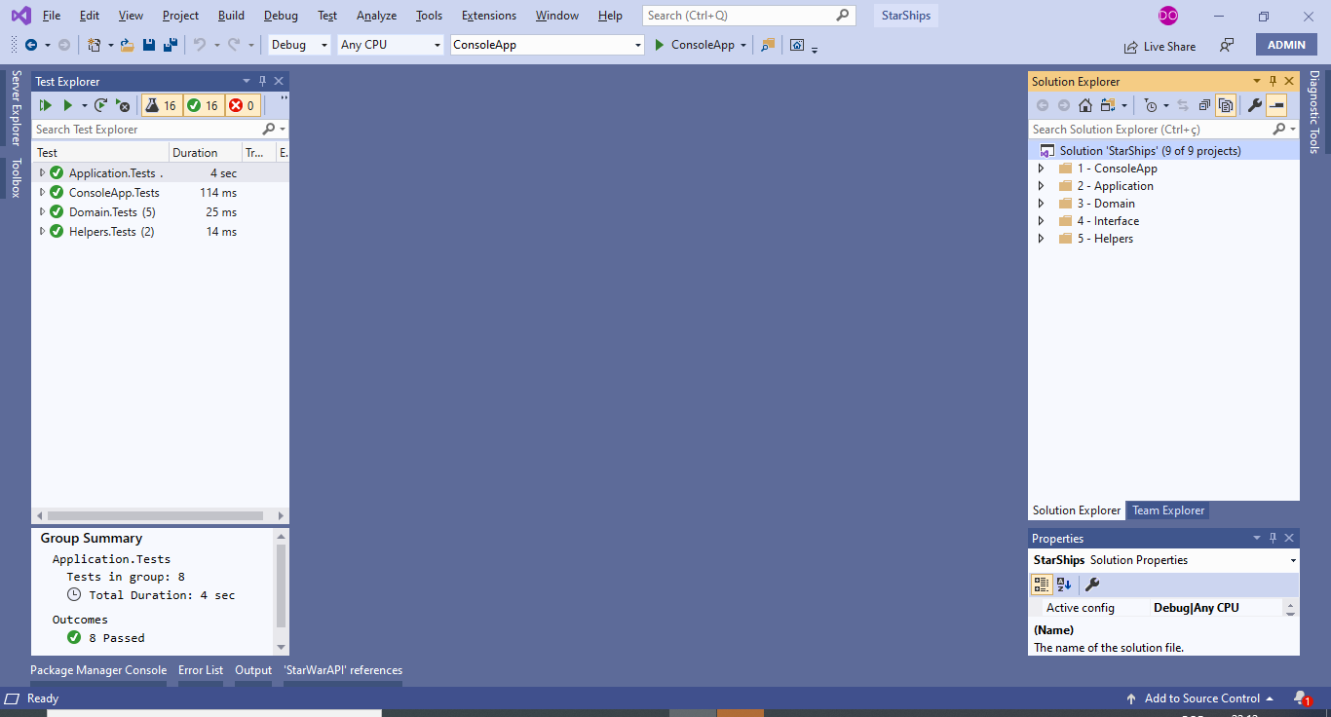

**1 – ConsoleApp**

Console Application (Main Entry)

**2 – Application**

Execute reading Star Ships from Star Wars Web API and treatnments for output information

**3 – Domain**

DTO Classes for returning data from Web API

**4 – Interface**

Contract for methods in application layer

**5 – Helpers**

Facilitators to get tags from App.config and message data.

**Others details:**

XML documentation was used in all methods, then you can understand easily the purpose of each.

NUnit was used for unit tests.